ML ENGINEER – VADEPEER

OBJECTIVE:

The output should be in the form of visualizations graphs- bar plot, map plot, prediction plots for overall India and state wise. Try to use many latest plots.

Excellent visualization making website: [Navigate Me!](https://lookerstudio.google.com/visualization)

PROCEDURE:

Please follow the below links for your development:

Cool! There are few steps need to followed before diving into Machine Learning:

Step 1: Know the concept of [Data analysis](https://youtu.be/Ea_KAcdv1vs?si=k0UfLJu5fETlKJC5)

Step 2: Use this dataset:

[Dataset 1](https://drive.google.com/file/d/1-JqRA47j_jZPyoX4mQoeVHVzr0piIsYk/view?usp=sharing)

[Dataset 2](https://drive.google.com/file/d/1aNRKns4t1JGXaH1LnWHhD6sjmgh6j3wg/view?usp=sharing)

Step 2: Apply random forest and support vector machine algorithm:

[No worry!!! This is my google colab link… code in it!](https://colab.research.google.com/drive/1rgPNEfWvfY3WX40Anqman7V9kWJF4U-W?usp=sharing)

Step 3: Still worry about visualization? No problem this [DRIVE LINK](https://drive.google.com/file/d/1aNRKns4t1JGXaH1LnWHhD6sjmgh6j3wg/view?usp=sharing) contains code for map- based visualizations.

Step 4: If still facing shortage of resources then navigate to BARD AI.

OUTPUT:

Example output plots for SVM.

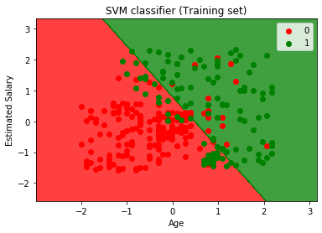

Example output plot for RF:

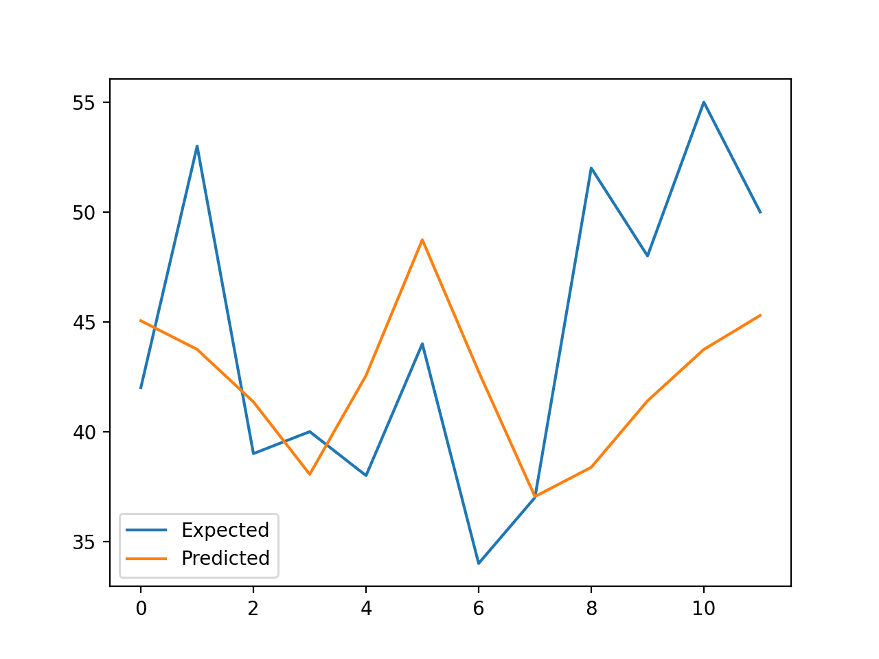

Example output for Random forest- ROC curve:

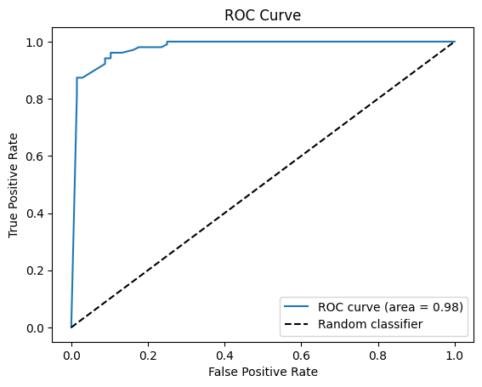

RESULT:

Thanks for tunning up the journey by making a best interactive website. Submit your work first to me after the discussion update in [SIH DIRECTORY LINK](https://drive.google.com/drive/folders/1bfutEb4Hx85bq7Rq1BIgvNJ0kvWGXTJV?usp=sharing) with your visualization and code folders. Rate my resources out of 5stars.

Thank you !!! Wait for tasting the success!!!